Practical 8:
MySQL Schema Design, ER Model, PDO Connectivity, and Prepared Statements
Problem Definition
Design the database for StudentHub with students, events and
registrations. Create PHP database connection using MYSQL statements.
Theory :

1. Is the schema normalized properly? Yes, the database is normalized to reduce duplicate data.
2. Are primary keys and foreign keys correctly defined? Yes, primary keys uniquely identify records, and foreign keys connect related tables.
3. Is the database connection handled securely? Yes, the database connection uses secure credentials and proper error handling.
Implementation/out put/result:
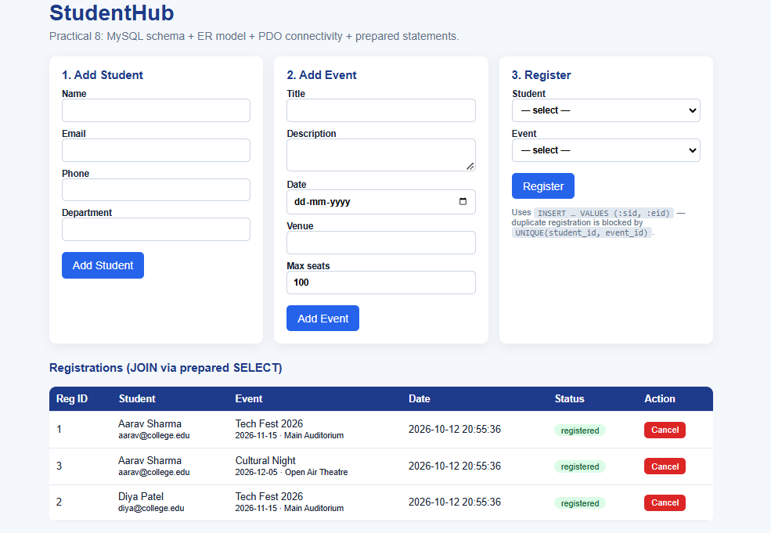
Git hub link:
https://github.com/Ayushsavaliya0305/25dce104-web
Learning outcomes:
the database is normalized to reduce duplicate data and maintain consistency.
2. Are primary keys and foreign keys correctly defined? Yes, primary keys uniquely identify records, and foreign keys maintain relationships between tables.
3. Is the database connection handled securely? Yes, the database connection is handled securely using proper credentials and prepared statements.

Faculty remarks:

